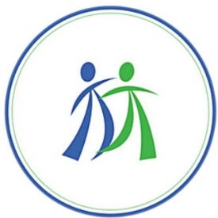
MoCLE Certificate of Attendance

Kids’ Chance of Missouri
Annual Workers’ Compensation
CLE Seminar 2024
9 hours of MoCLE Credits
Including 2 hours of Ethics & 1 hour Diversity

Hours are due 6-30-2024; CLE report due 7-30-2024
MO Bar CLE# 741704
KS Bar CLE# 211806
Friday, May 31, 2024
Virtual Webinar
James A. Susman
Executive Director
KIDS’ CHANCE Inc. of Missouri
Please keep this certificate for your records. It will assist you in completing the Attorney’s Annual Report of Compliance,
which individual attorneys are required to submit to The Missouri Bar.

